How to get
from the ICRERA 2025 conference venue
(Fachhochschule Technikum Wien, Main Campus, Building F, Höchstädtplatz 6, 1200 Wien)
to the GALA DINNER
(Heuriger 10er Marie, Ottakringerstraße 222-224, 1160 Wien)

The best way is to use public transport (find routes in Vienna public transport with the website: https://www.wienmobil.at/en/monitor/PT):

Option 1 (Takes about 35min. Recommended because there is no stop-over.):
- Walk about 500m (8min) from Höchstädtplatz to Handelskai S-Train station
- Take S-train S45 (direction Penzing) from Handelskai S-train station (departs every 10 minutes, 17:38, 17:48, 17:58, 18:08,…)
- Ride S-train S45 for 6 stations and depart at Ottakring S-train station.
- Walk about 500m (8min) from Ottakring S-train station to Heuriger 10er Marie, Ottakringerstraße 222-224, 1160 Wien.
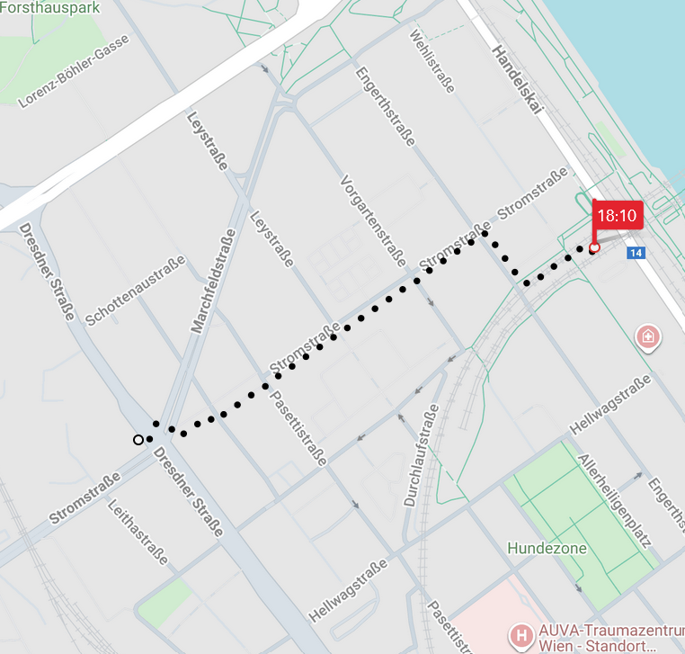 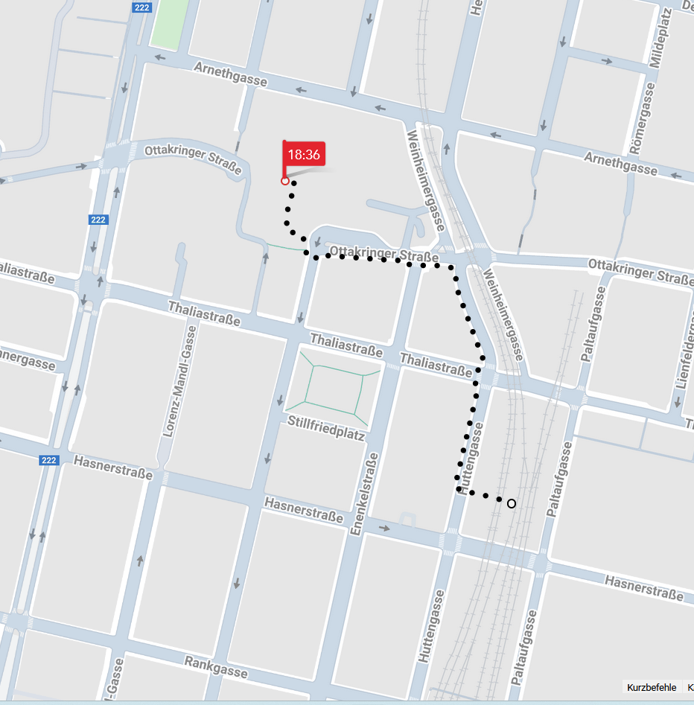
Walk from Höchstädtplatz to Handelskai S-Train station Walk from Ottakring S-train station to Heuriger 10er Marie

Option 2 (Takes about 45min. There is one stop-over.):
- Take tram Nr 12 from Höchstadtplatz (direction: Josefstädter Straße)
- Ride tram Nr 12 and depart at Lange Gasse tram station
- Change at Lange Gasse tram station to tram Nr 44 (direction: Maroltingergasse)
- Ride tram Nr 44 and depart at Johannes-Krawarik-Gasse tram station
- Walk about 60m (2min) from Johannes-Krawarik-Gasse tram station to Heuriger 10er Marie, Ottakringerstraße 222-224, 1160 Wien.

